# Installation

1. Python

Go to Softwareshop ,

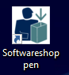

search ‘python’, choose ‘Python v3.9’

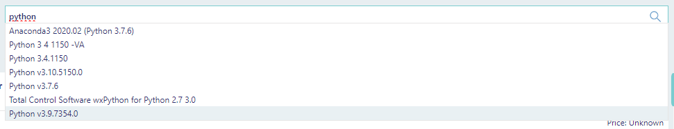

1. Pycharm

* Go to the webpage of Pycharm ‘https://www.jetbrains.com/pycharm/download/?section=windows’,
* Choose the ‘PyCharm Community Edition’, and click ‘Download’

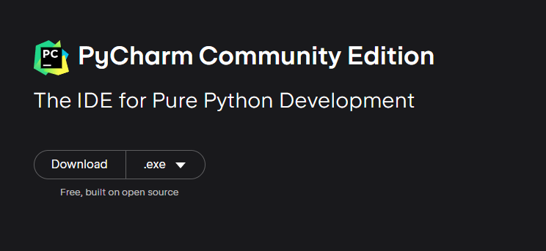

* When you see ‘User Account Control’, you click ‘No’, then you can continue to install PyCharm, click ‘Next’ all through and ‘Finish’.

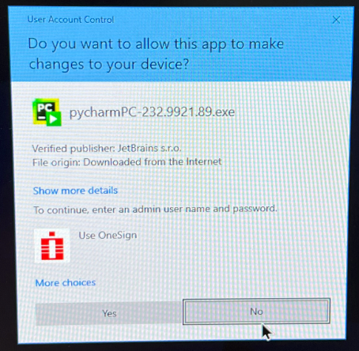

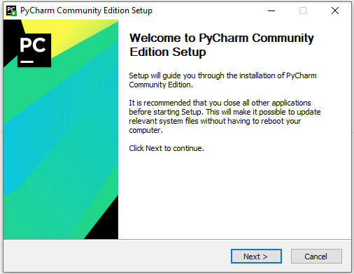

# Usage with PyCharm

* Copy the pipeline folder (L:\LovbeskyttetMapper\PRODSPN\ODiNe\GCMS targetted metabolomics python pipeline) to your local drive (desktop or downloads etc).
* Open the installed PyCharm, click ‘New Project’, locate the pipeline folder, choose the installed python as interpreter, and click ‘create from existing sources’. By default, you will also have a virtual environment folder ‘venv’ generated inside the pipeline folder (all packages will be installed inside).

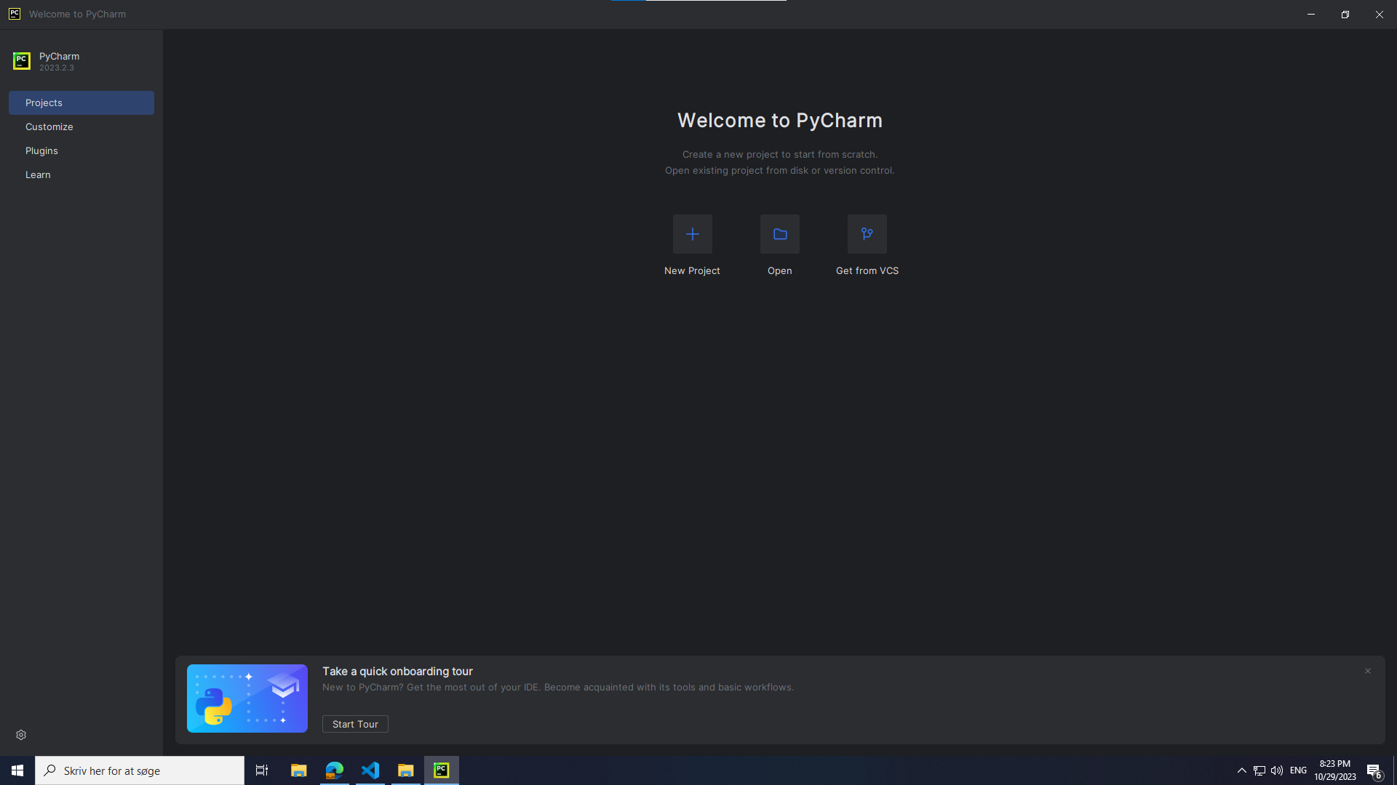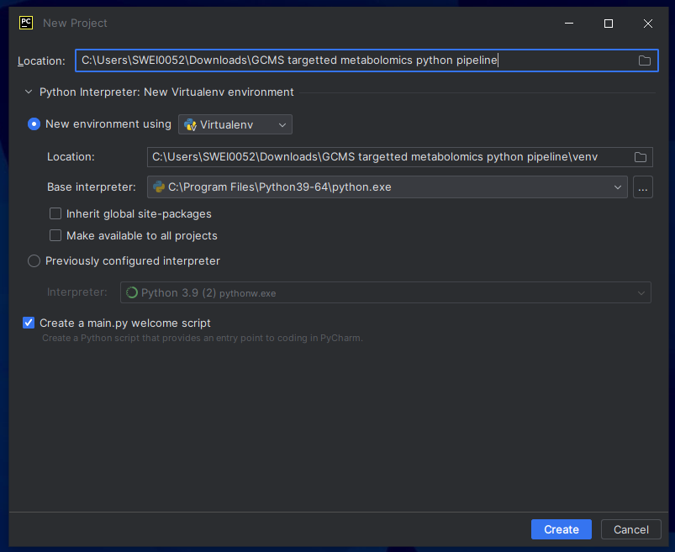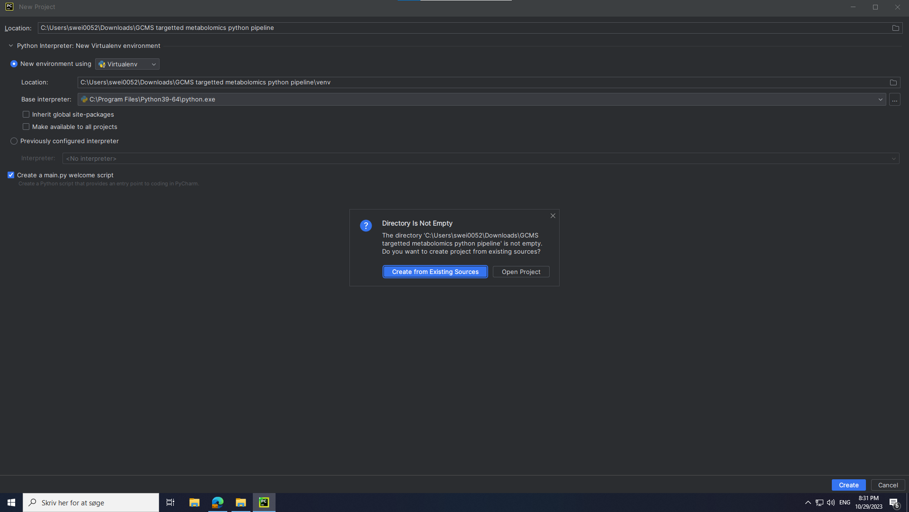

* In case the interpreter and ‘venv’ folder are not properly set up (skip it if you have seen ‘venv’ folder generated), you can set up python interpreter for PyCharm by clicking ‘setting’, choose the Python you have installed, and set up the virtual environment (a ‘venv’ folder, all needed packages will be installed inside).

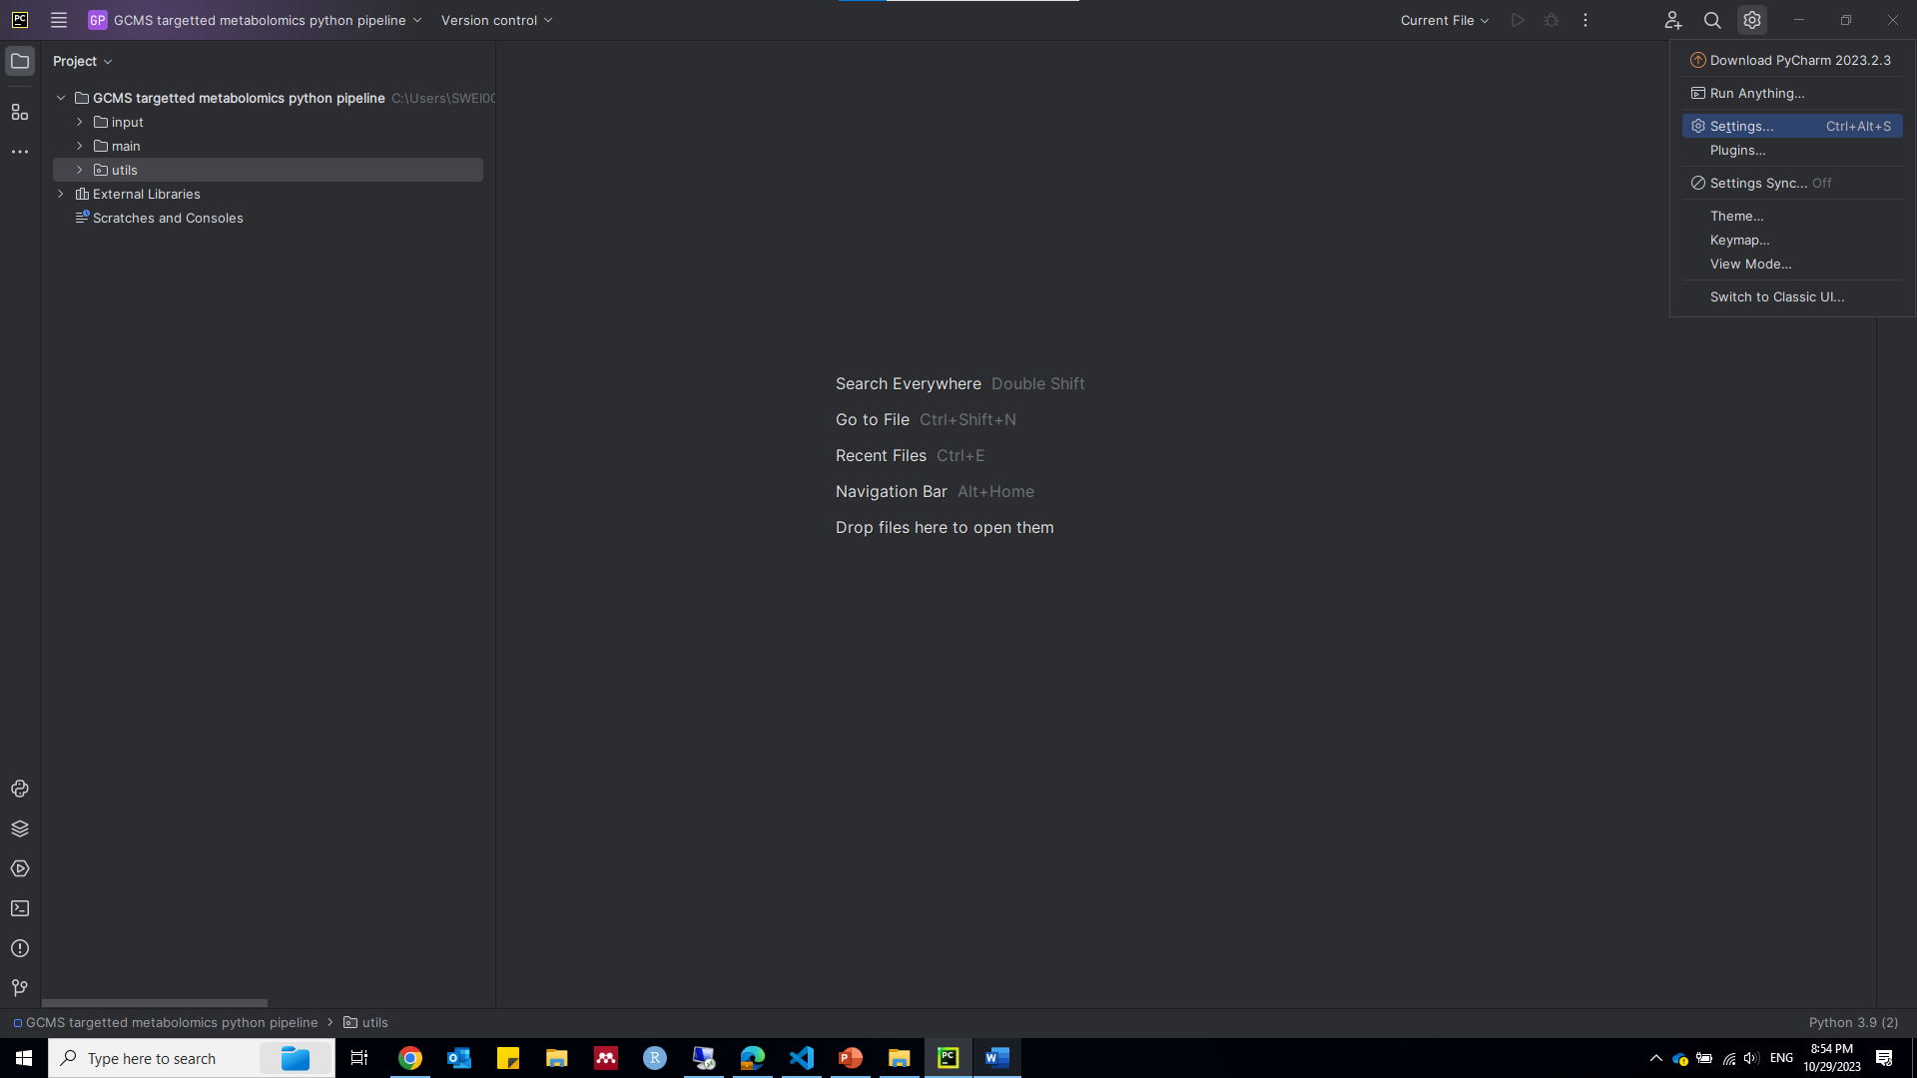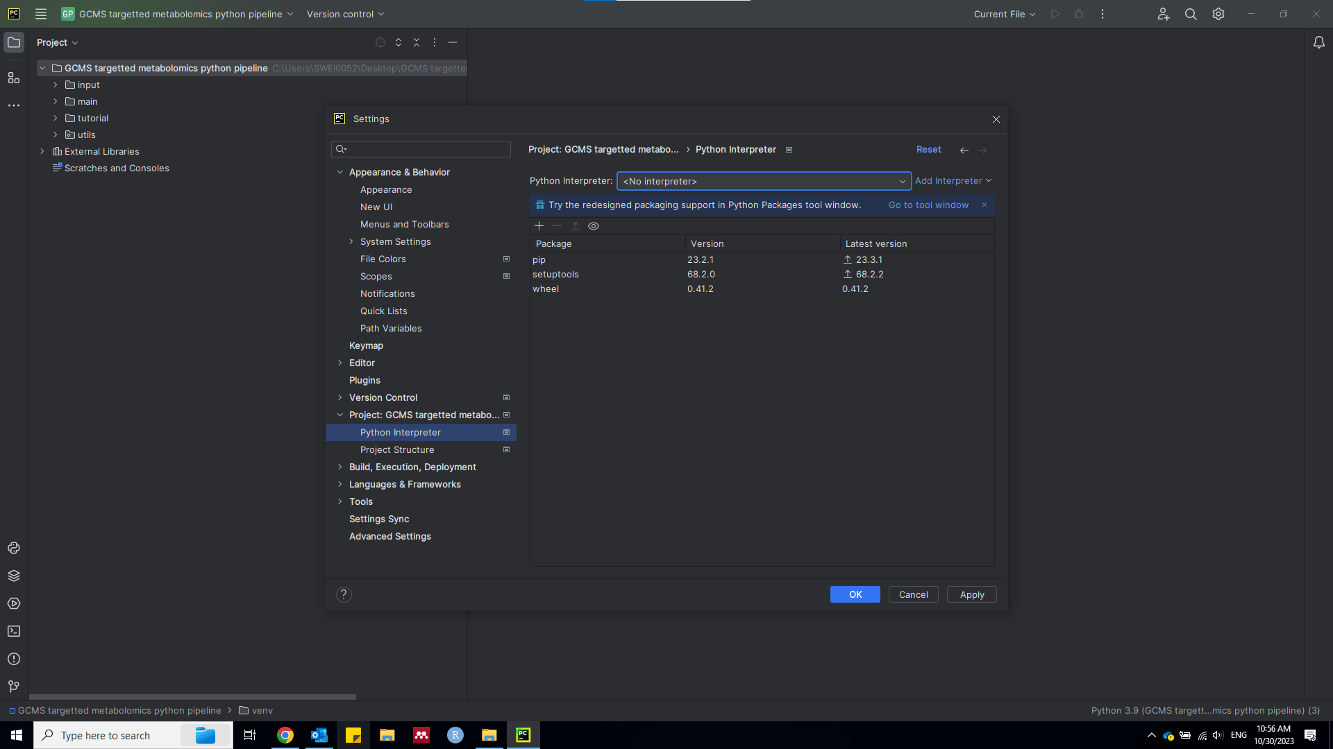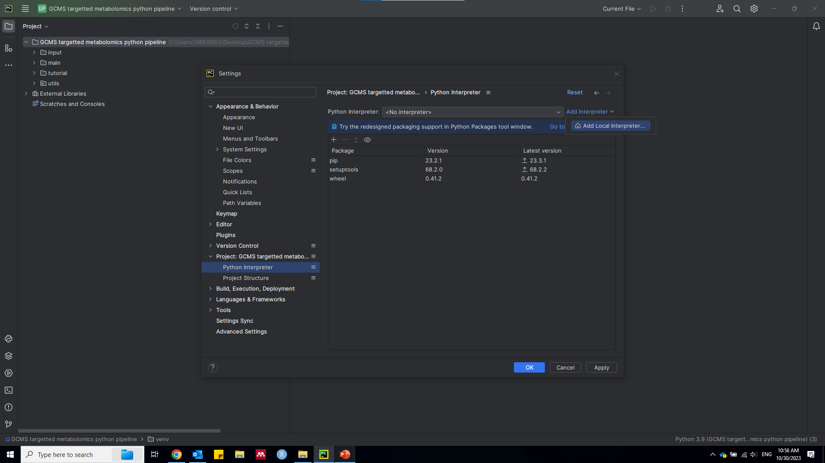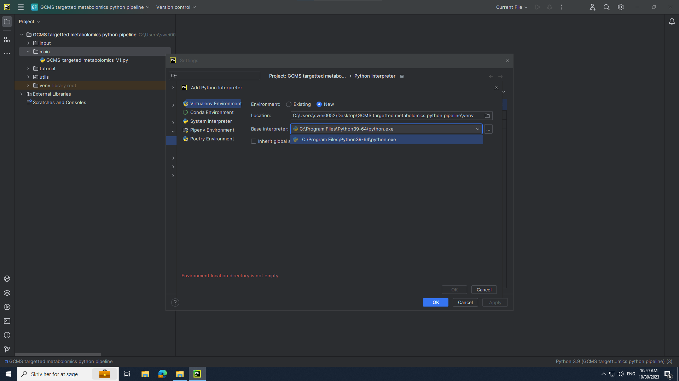

* Click ‘utils’, double click ‘packages_installation.py’ to open it,

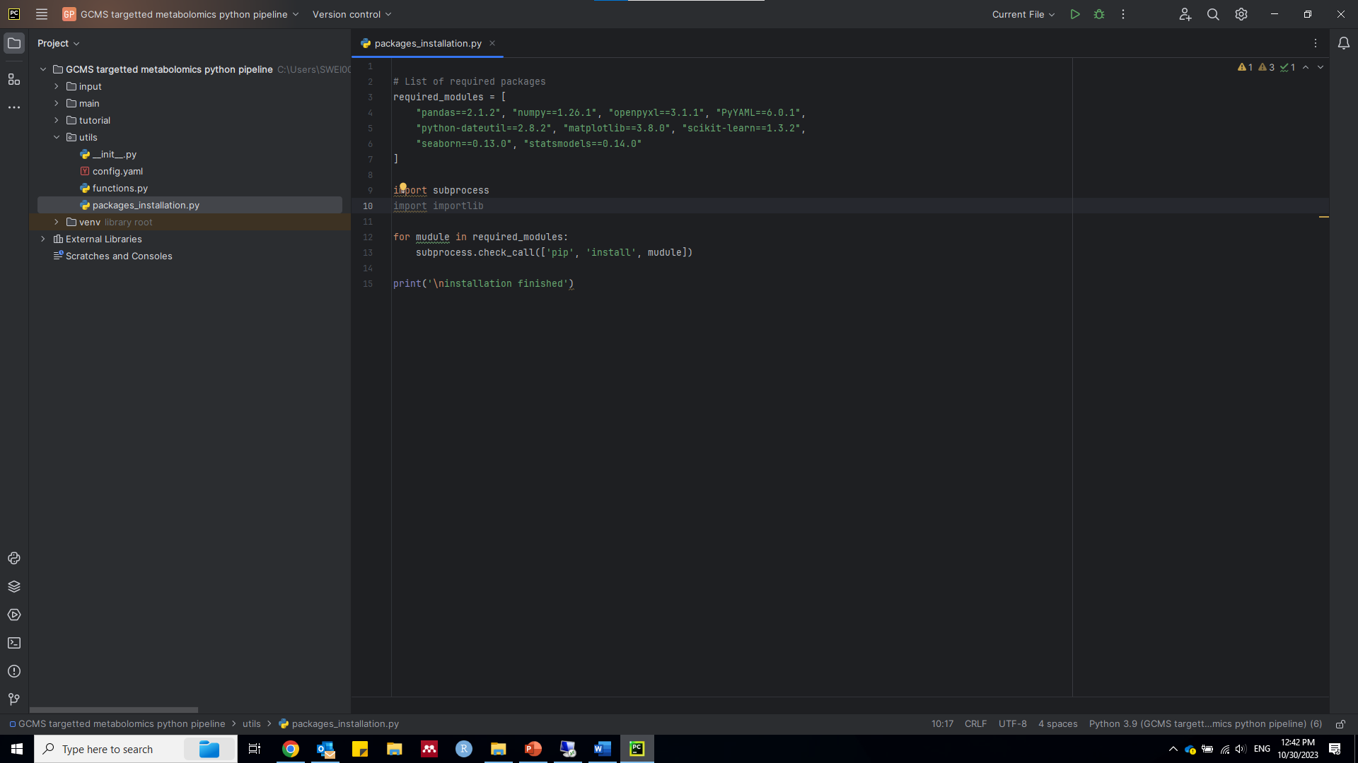

* Click ‘Edit Configuration’ to configure the script file.

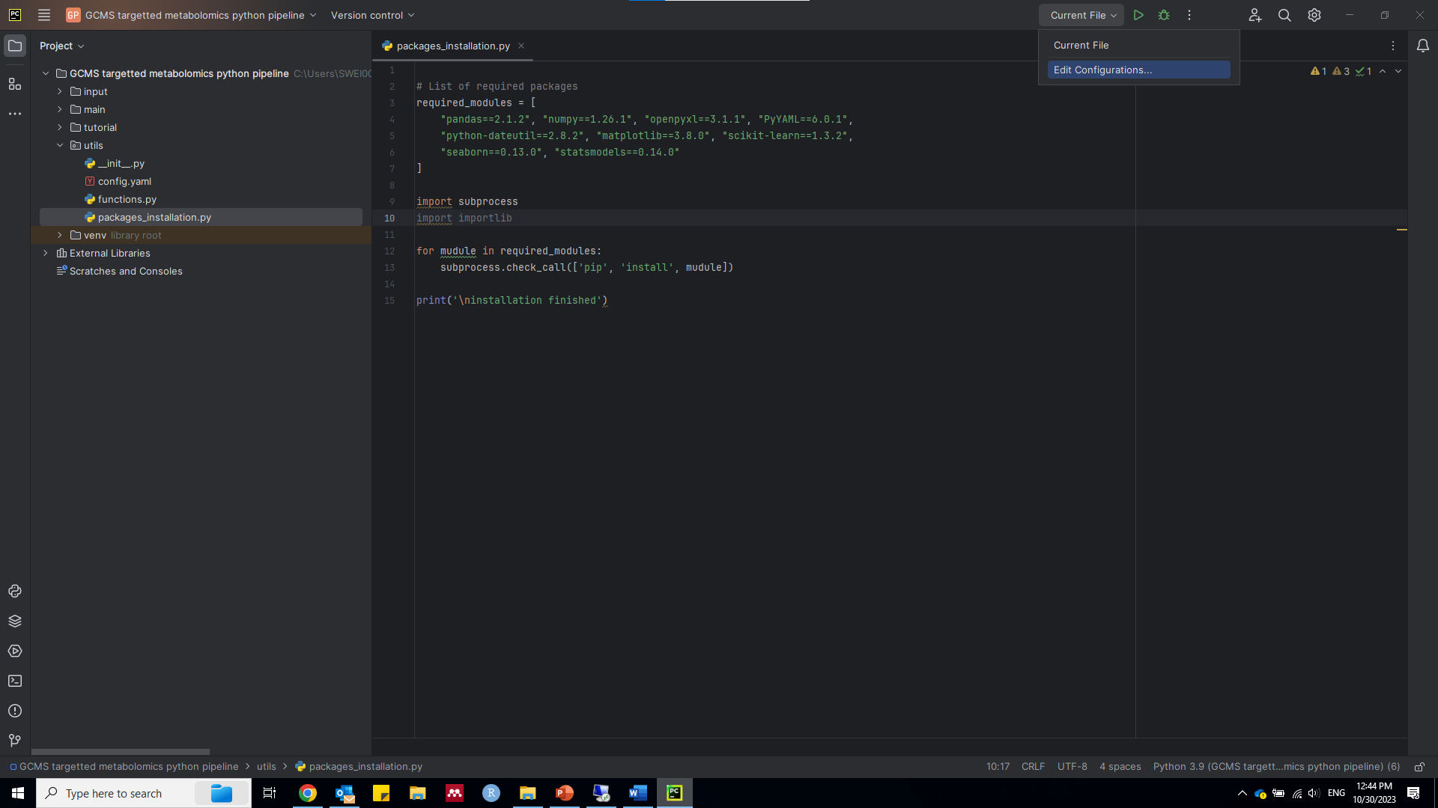

* Add new python configuration

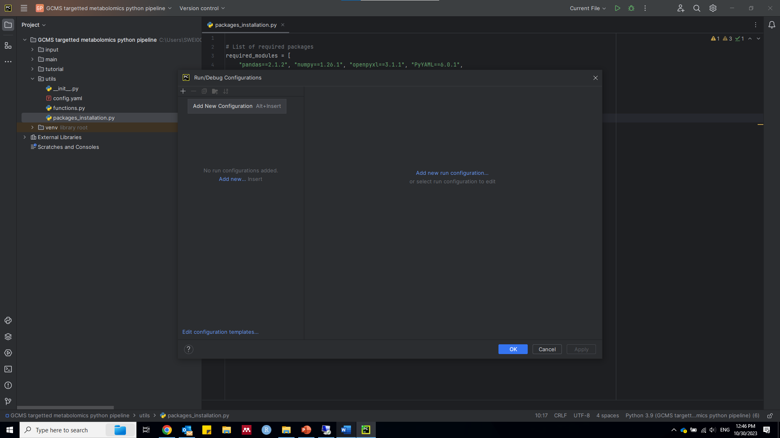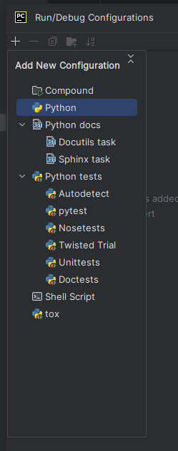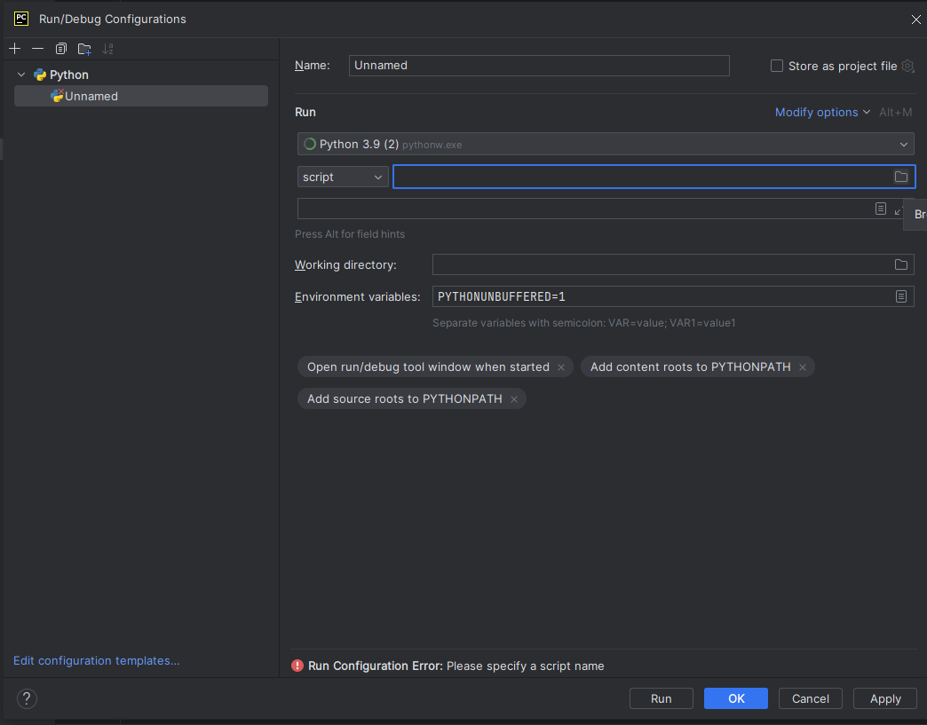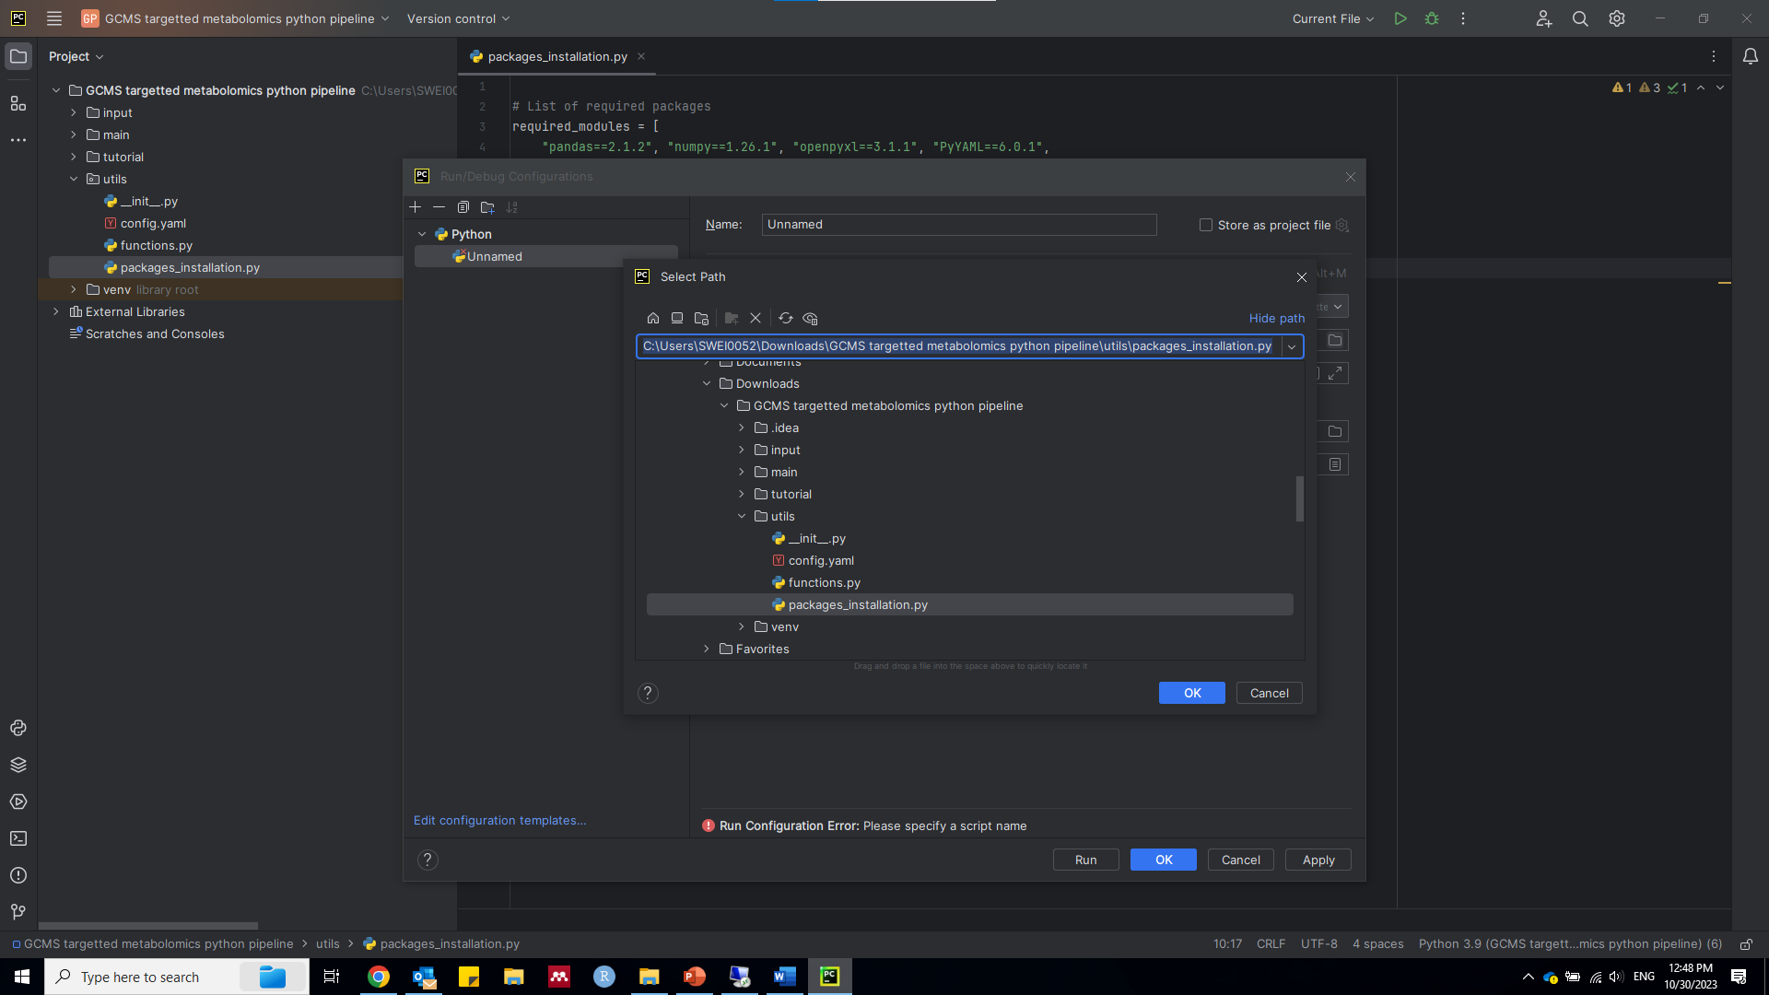

* Now, you are ready to install required packages by clicking the triangle button 

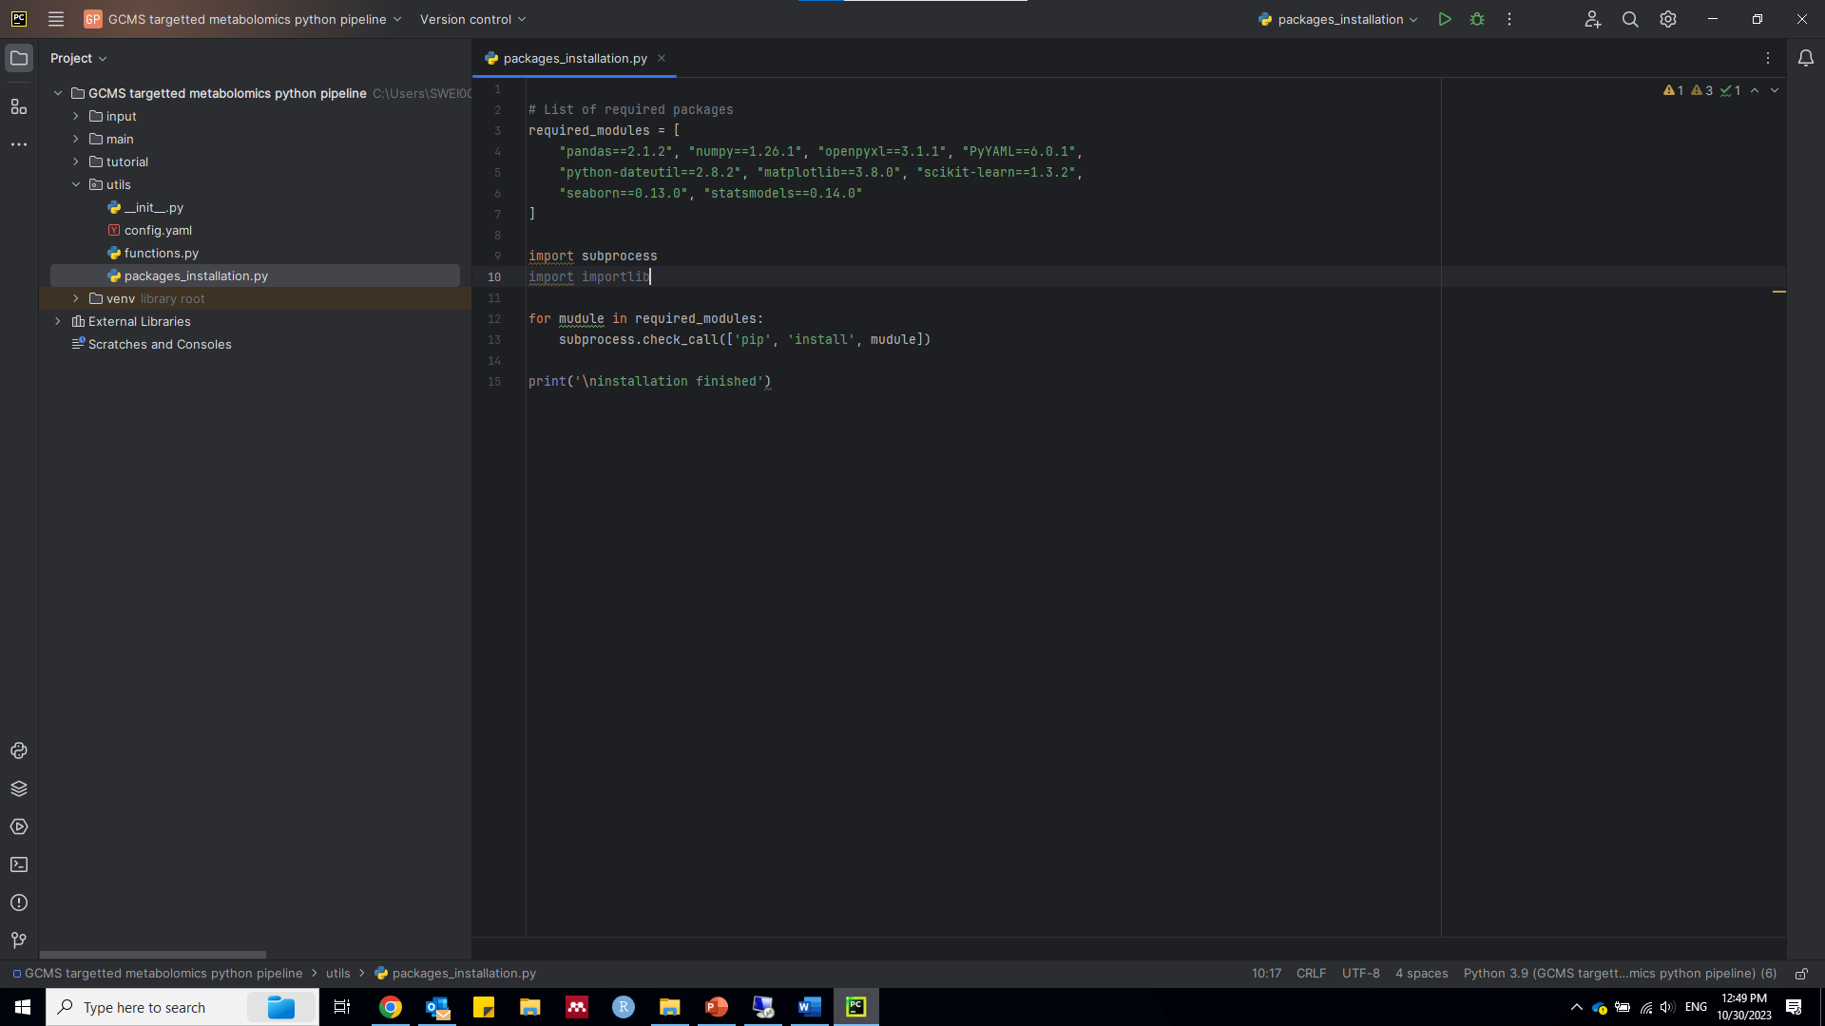

* Double click the ‘config.yaml’ file, start setting up your parameters carefully, put your single to-be-analyzed table (e.g. excel or csv) in the ‘input’ directory.

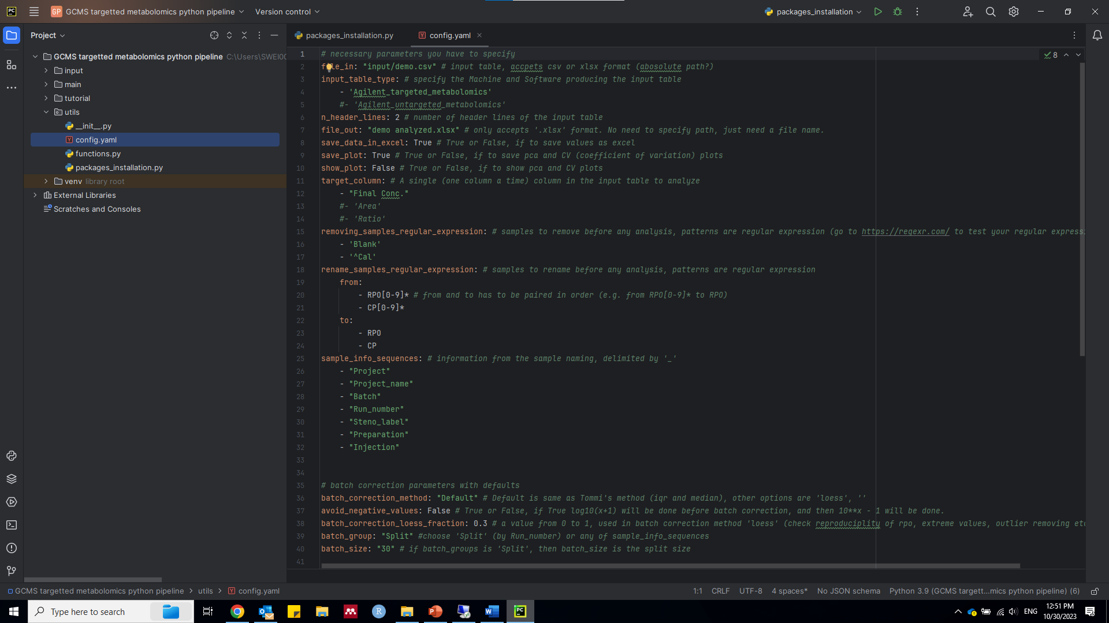

* Click the ‘main’ directory, and double click ‘’GCMS targeted metabolomics v1.py”, configure this script file using same method as for ‘packages_installation.py’, after correctly configured, you will see the script file name as shown in the red arrow. Now you are ready to click triangle button  to analyze your data, analyzed outputs will be saved inside the ‘input/output’ folder.

